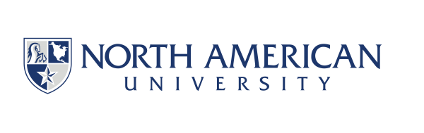
North American University
Research Center Fellowship Application Form

Instructions: Please fill out the form and email it to researchcenter@na.edu along with other required documents.

Personal Information
Full Name : ___________________________
Date of Birth : ___________________________
Email : ___________________________
Phone Number : ___________________________
Address : ___________________________

Academic Information
Current Institution : ___________________________
Department : ___________________________
Highest Degree Earned : ___________________________
Year of Graduation : ___________________________
Research Interests : ___________________________

References
Please provide contact details of two academic or professional references:

Reference 1
Name : ___________________________
Institution : ___________________________
Email : ___________________________
Phone Number : ___________________________

Reference 2
Name : ___________________________
Institution : ___________________________
Email : ___________________________
Phone Number : ___________________________

Declaration: I hereby declare that the information provided is true and accurate to the best of my knowledge.
Signature : ___________________________
Date : ___________________________

ADDITIONAL DOCUMENTS REQUIRED (Applications with missing documents will not be accepted).
- Curriculum Vita: Please provide a detailed academics CV including the research activities participated in.
- Transcripts of all graduate degrees: Please provide your graduate transcripts (both master’s and doctoral, if applicable).
- Statement of Purpose: Please provide a brief statement (300-500 words) explaining your research interests and motivation for applying.

For Official Use Only
Reviewed by : _________________
Date : _________________
Decision: Approved / Not Approved
Comments : _________________

